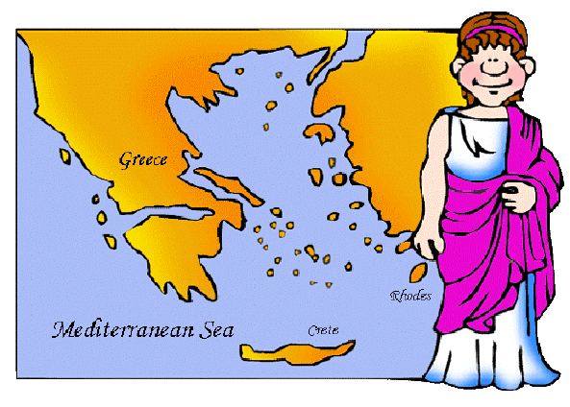Name: _________________________ Date: ____________

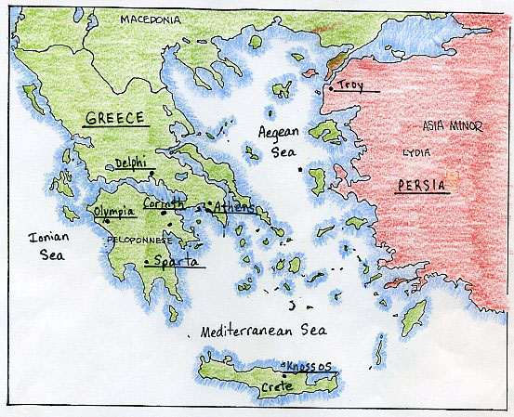

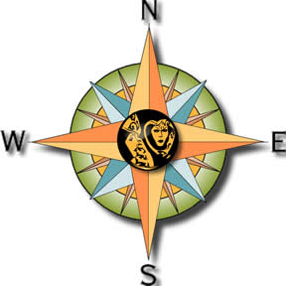

Directions: Use the map to answer the following questions.

1. Name the Island to the south of Greece. ______________________________________

2. Name the body of water to the south of Peloponnesus. ____________________________

3. Name the body of water to the west of the peninsula of Greece. _____________________

4. Name the Sea to the East of the Peninsula of Greece. ____________________________

5. How is the geography of Greece different from the other civilizations we’ve studied? ____

_______________________________________________________________________

_______________________________________________________________________

Directions: Read each statement and decide if it represents an affect of the Mountains or Seas on Greece. Write Mountain or Sea on the line provided.

6. There was little farmland. ___________________

7. These were a source of food. ___________________

8. These separated villages and towns from each other ___________________

9. These was a way to trade with other civilizations ___________________

10. These made travel difficult ___________________

11. These helped transportation ___________________

12. These allowed for little contact between towns ___________________

13. These helped the Greeks exchange ideas with other cultures. ___________________

