Social Studies 6 Name _______________________ Middle Ages Unit Date ________________________
How a Boy became a Knight in Medieval Times
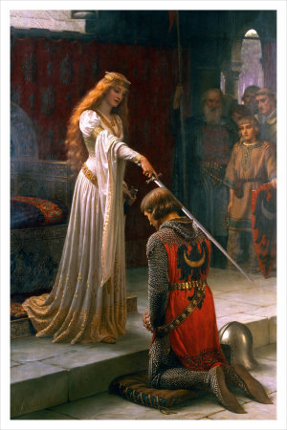
The Accolade, c.1901

For almost seven hundred years, between the ninth and sixteenth centuries, knights were the lords of the battlefield, admired and respected for their fighting abilities and for their chivalry and courage. So how did a boy in these centuries become a knight?
The Rule of Birthright The first requirement for a boy to become a knight was the requirement of his heritage. Only boys born to certain men were allowed the opportunity to become a knight. These requirements were usually that the boy be the son of a knight, Lord, a wealthy merchant, or someone who held title and position in the court of the king or a lord.
Where Training took place Contrary to popular belief, the king did not train boys to become knights. This was the responsibility of the king’s lords, barons and knights. Each of these men held titles, lands and manors, and it was to the lord’s manor that the boy would go to train. Over the centuries, what a knight was expected to do changed and chivalry did not come into the picture until the late Middle Ages.
Training Begins as a Page At around the age of six or seven a boy, who was of noble heritage, would report to the local lord’s castle or manor to begin his training as a knight. There he would learn a host of basic skills to make him a well-rounded and educated knight. He would learn the fundamentals of court life such as table manners, care and maintenance of armor and weapons, and how to care for a horse. He would also learn how to read and how to appreciate music or even play the lute. His training would begin in the martial arts with his learning how to hunt and how to hawk.
The Page Becomes A Squire At around the age of thirteen, as the boy started to develop the body, mentality, strength and abilities of manhood he was promoted to squire. He was then assigned as the personal assistant to a knight and would focus on the combat arms of knighthood. He would get intensive training in weapons, armor, tactics and mounted combat. He was allowed to carry a small sword and shield with him as a symbol of his status as a squire or a “knight in training”.

Becoming a Knight – The Ceremony of Knighthood The ceremony of becoming a knight could often last several days and could include fasting or a Vigil, where the knight would engage in prayer and contemplation for a day and a night or longer. Then there would often be elaborate feasts and hardy discussions with lords and knights about chivalry, courage, religion, and the nature of being a knight. During the actual knighting ceremony the knight would swear allegiance to God and to his lord and he would receive presents such as a sword, spurs, armor, and a cloak. At the end of the ceremony the king would tap the squire on the shoulders with the flat side of a sword blade and he would become a knight.
In modern times we have a very romanticized view of knights. There is a certain mystery around the idea of knighthood. It was a serious path that a boy embarked on and something that he spent his whole childhood striving for and his whole adult life improving. The life of a knight was a life of constant vigilance in combat and constant striving toward improvement in the eyes of others.
1-7. Write one of the bold, underlined words from side 1 of the reading next to its synonym or definition:
Synonym/Definition | Word from reading
1. related to war
2. rank or position
3. very thorough
4. approved of
5. advanced
6. family background
7. a code of conduct for knights

8-13. Write one of the bold, underlined words from side 2 of the reading next to its synonym or definition:
Synonym/Definition | Word from reading
8. loyalty
9. struggling
10. got started on
11. deep thought or meditation
12. refusing to eat
13. caution and careful attention

14. The son of a _____ could not become a knight. A. knight B. farmer C. lord D. wealthy merchant
15. Boys went to the lord’s _______ to train for knighthood. A. farm B. country C. church D. manor
16. List three things a boy learned as a page: ____________________________________________________________
17. List three things a boy learned as a squire: ___________________________________________________________
18. Do you think a knight from the Middle Ages would fit in better in Athens or Sparta? Explain your answer with
at least two reasons.

__________________________________________________________________________________________________

__________________________________________________________________________________________________

__________________________________________________________________________________________________

__________________________________________________________________________________________________

__________________________________________________________________________________________________

