Name: ____________________________ Date: ___________________ Block: _______________
Geography of Egypt
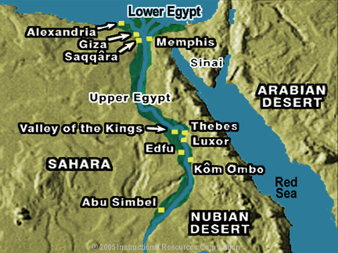

Step #1: Draw a around the delta
Step #2: Highlight Upper and Lower Egypt
Step # 3: Label the Mediterranean Sea

Read the passage to help you fill in the web on the back.
The Nile River forms in Khartoum, Sudan, at the meeting place of the White Nile and Blue Nile rivers. The White Nile provides the majority of the Nile’s water.
From Khartoum, the Nile flows northward to Egypt. At Cairo the Nile fans out into its delta, a fertile area created by sediment from the river, deposited as the river empties into the Mediterranean Sea.
As the Nile flows north through Egypt, it creates a thin strip of fertile land along its banks. This green, fertile land is in sharp contrast to the barren desert on either side of the river valley.
The flooding of the Nile River occurs in a cycle with three seasons.
In the spring, heavy tropical rains in Ethiopia flood the Nile at its source. These flood waters move north toward Egypt carrying with them nutrient-rich soil, also called silt, from the Ethiopian highlands. Ancient Egyptians called the Nile River Ar or Aur, which means “black,” for the color of the silt it carried.
Every year, the Nile floods and silt-rich water flows over the floodplain—the flat land around the river. When the water recedes, the silt that it carried gets left behind on the land. These silt deposits enrich the soil that fills the Nile River Valley and delta, making them very fertile.

Nile River

