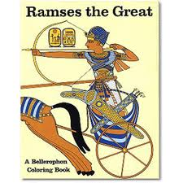
Ramesses II
“Ramesses the Great”
(1279-1213BC)

Ramesses II was one of the longest ruling pharaohs of ancient Egypt. He ruled for 67 years, although beside his father in the beginning. It is said that Ramesses lived for over 80 years. The average person lived to about 40 so he must have seemed like a god. Ramesses made a name for himself as a builder and a warrior but he also had a rep as a ladies man.
When Ramesses II became pharaoh, the neighbors sent warriors to see what would happen. Ramesses II was a brave man, a good husband, and a loving father. Ramses was also a peacemaker He and the Hittites signed the world's first peace treaty. This peace lasted until the Hittite Empire collapsed. One of Ramses' most impressive projects was the temple complex at Abu Simbel. The main temple was carved into the side of a cliff on a bank of the Nile River. A smaller temple honored his favorite wife, Nefertari. Some remember Ramesses as the Pharaoh who had 111 sons, 51 daughters, and many wives. Others recognize his name because he ordered the construction of the temple of Abu Simbel, the huge temple that is 180 feet long, 90 feet high, and decorated with four 60 foot high statues of Ramesses II. But in ancient Egypt, people knew his name because Ramesses ordered his name chiseled on everything. He even had his name put on statues that were not statues of himself. He did this to bolster people’s confidence in his leadership abilities.
Today, his name is still found in Egypt on ancient buildings. But it was not his chiseling that kept Egypt safe. Egypt was strong enough to survive his 60-year rule. Egypt was an ancient world power. Her reputation, supported by capable leaders in the military, kept Egypt safe.
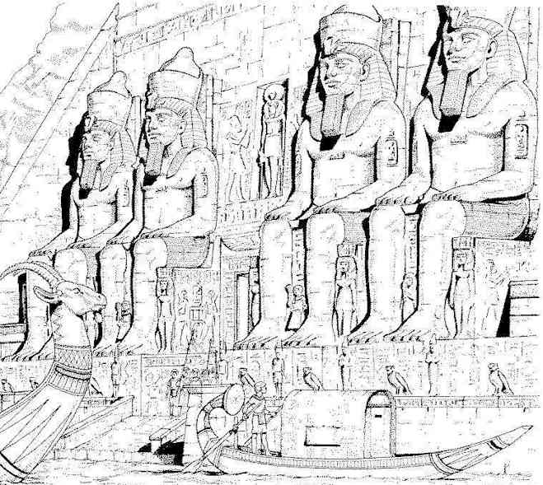

King Tutankhamen
King Tutankhaten
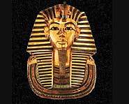
“King Tut”
(1336 - 1327 BC)

At the age of nine Tutankhamen became pharaoh. King Tut, as a lot of people call him, was too young to rule Egypt so his uncle Ay, who was the highest minister, ruled for him while he was a boy. Tut married Ankhsenoomun. Tutankhamen died at 18. His body was found with his skull bashed in. It is thought that Ay may have had something to do with the sudden and mysterious death. Only a person of great importance could get near enough to harm him, one of them would have been Ay. Ay married Tut's widow (who is also a suspect in Tut's murder), despite being her grandfather, so that he could have power.
Tut was only nine years old when he became Pharaoh. He was only 18 years old when he died. The people did not have a lot of time to build Tut's tomb. Tut's tomb was very small compared to the tombs of other pharaohs.
Because his tomb was so small, it was overlooked for thousands of years.
In 1922, a British archaeologist named Howard Carter entered King Tut's tomb. It was almost like entering a time machine.
Robbers might have been there because a bag of gold rings was found on the floor, as if dropped in haste. But they did not take everything because Carter and his team found many treasures inside the tomb including a solid gold mask of King Tut's face.
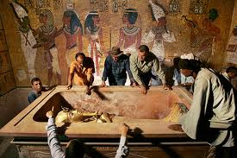
The artifacts in Tut's tomb told archaeologists and scientists a great deal about ancient Egyptian daily life. Many people all over the world became interested in learning more about ancient Egypt because of the exciting discovery of an ancient tomb full of treasure.
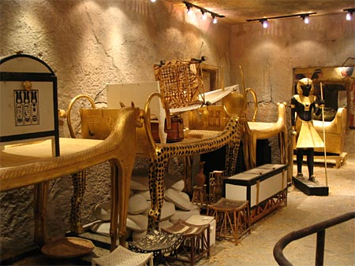

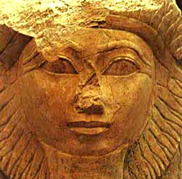
Queen Hatshepsut
(Hatshepsut the Woman Who Was King)
(1479 - 1457 BC)

Her rise to power went against all the conventions of her time. She was the first wife and Queen of Thutmose II and on his death proclaimed herself Pharaoh, denying the old king's son, her nephew, his inheritance. To support her cause she claimed the God Amun-Ra spoke, saying "welcome my sweet daughter, my favourite, the king of Upper and Lower Egypt, Maatkare, Hatshepsut. Thou art the King, taking possession of the Two Lands." She dressed as a king, even wearing a false beard and the Egyptian people seem to have accepted this unprecedented behaviour.
She remained in power for twenty years and during this time the Egyptian economy flourished, she expanded trading relations and built magnificent temples as well as restoring many others. Eventually her nephew grew into a man and took his rightful place as pharaoh. The circumstances of this event are unknown and what became of Hatshepsut is a mystery.
Hatshepsut's successor became the greatest of all Pharaohs, Thutmose III, "the Napoleon of ancient Egypt." He had her name cut away from the temple walls which suggests he was not overly fond of his auntie.
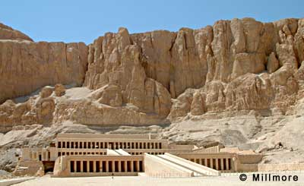

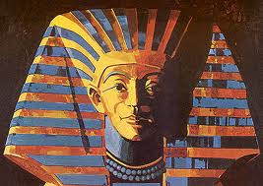
Khufu
“The Pyramid Builder”
(2609 BC - 2584 BC)

The Egyptian pharaoh Khufu was the second pharaoh of the Fourth Dynasty, famous for building the Great Pyramid at Giza.
Khufu's full name was Khnum-Khufwy, which means '[the god] Khnum protect me'. He was the son of Sneferu and Queen Hetepheres I, and is believed to have had three wives. He is famous for building the Great Pyramid at Giza, one of the seven wonders of the world, but apart from this, we know very little about him. His only surviving statue is, ironically, the smallest piece of Egyptian royal sculpture ever discovered: a 7.5 cm (3 inch) high ivory statue found at Abydos.
Khufu came to the throne, probably during his twenties, and at once began work on his pyramid. The entire project took about 23 years to complete, during which time 2,300,000 building blocks, weighing an average of 2.5 tons each, were moved. His nephew Hemiunu was appointed head of construction for the Great Pyramid. Khufu was the first pharaoh to build a pyramid at Giza. The sheer scale of this monument stands as testament to his skills in commanding the material and human resources of his country. It is now believed the pyramids were built using conscripted labour rather than slaves. The idea that Khufu used slaves to build the pyramid comes from Greek historian Herodotus. He also describes Khufu as a cruel and wicked leader who prostituted his daughter when he ran short of money. But the Westcar Papyrus describes Khufu as a traditional oriental monarch: good-natured, amiable to his inferiors and interested in the nature of human existence and magic.
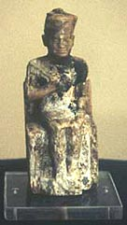
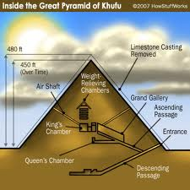
Despite not being remembered as fondly as his father, the funerary cult of Khufu was still followed in the 26th Dynasty, and he became increasingly popular during the Roman period

Directions: After your group has been assigned a leader you will research by reading the biography. Your group will use the biography of the great leader of Ancient Egypt to create one of the following products.
The following parts must be included in all of the options:
- Name of Leader
- Year born and Year died
- Picture
- 5 facts that are important to the reign of the leader
- 2 Interesting facts

Option #1: Create a poster on construction paper.
Option #2: Create a collage using the app PicCollage
Option #3: Create a glogster using glogster.edu

Directions: After your group has been assigned a leader you will research by reading the biography. Your group will use the biography of the great leader of Ancient Egypt to create one of the following products.
The following parts must be included in all of the options:
- Name of Leader
- Year born and Year died
- Picture
- 5 facts that are important to the reign of the leader
- 2 Interesting facts

Option #1: Create a poster on construction paper.
Option #2: Create a collage using the app PicCollage
Option #3: Create a glogster using glogster.edu

Directions: After your group has been assigned a leader you will research by reading the biography. Your group will use the biography of the great leader of Ancient Egypt to create one of the following products.
The following parts must be included in all of the options:
- Name of Leader
- Year born and Year died
- Picture
- 5 facts that are important to the reign of the leader
- 2 Interesting facts

Option #1: Create a poster on construction paper.
Option #2: Create a collage using the app PicCollage
Option #3: Create a glogster using glogster.edu

