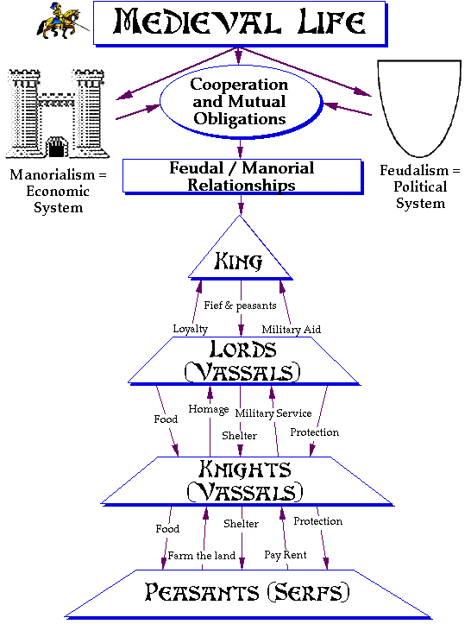
Feudal Oath taken by a vassal in the manor church: (“he” meaning feudal lord)

By the Lord (God) before whom this sanctuary is holy, I ___ will to be true and faithful, and love all which he loves and shun all which he shuns, according to the laws of God and the order of the world. Nor will I ever with will or action, through word or deed, do anything which is unpleasing to him, on condition that he will hold to me as I shall deserve it, and that he will perform everything as it was in our agreement when I submitted myself to him and chose his will.
Response of the feudal lord:
It is right that those who offer to us unbroken fidelity should be protected by our aid. And since _________, a faithful one of ours, by the favor of God, coming here in our palace with his arms, has seen fit to swear trust and fidelity to us in our hand, therefore we decree and command by the present precept that for the future_____________ be counted with the number of antrustions (term used to describe a free man who swears loyalty to the king). And if anyone perchance should presume to kill him, let him know that he will be judged guilty of his wergild (the term for value placed on a human's life) of 600 shillings.

from E. P. Cheyney, trans, University of Pennsylvania. Dept. of History: Translations and Reprints from the Original Sources of European history, published for the Dept. of History of the University of Pennsylvania., Philadelphia, University of Pennsylvania Press [1898]. Vol IV, No: 3, 3-5

