Name: ________________________ Date: ___________ Blk: ________
Physical vs. Political Map

Directions: Compare and contrast the 2 map styles. Use the format below to complete assignment. Make sure you use a variety of resources help you complete the chart. You must include 3 facts and 3 visuals for each part of the Venn Diagram.

Resources:
1. BrainPop “Map Skills” www.brainpop.com
2. Discovery Education Course: World GEOGRAPHY 1.1 pg 6 “Maps” www.discoveryeducation.com

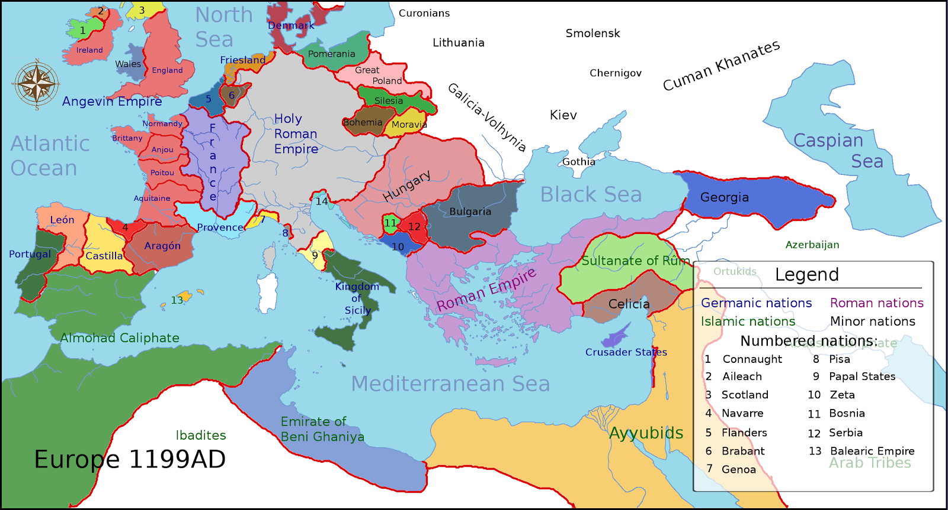
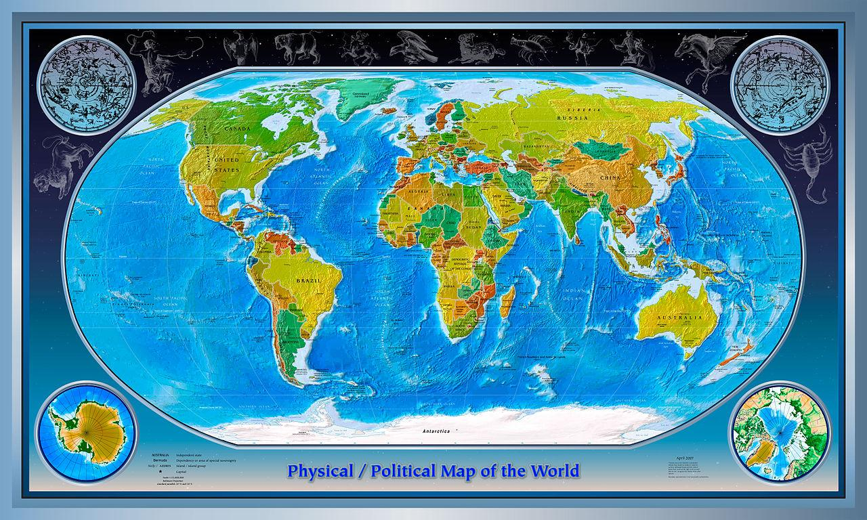

Physical Map Political Map

